Annual Membership $60 per year
Junior Membership 18 – 25 years of age $25 per year

October 1 thru September 30

Applicant
Name:
Email Address: |  |  | Phone:
Mailing address:
City: | State: |  | ZIP Code:

Spouse:

Boat name and model:
Interests
Off shore fishing |  | Oyster Reef Restoration
Inshore Fishing |  | Indian River Lagoon Restoration
Serve on Board of Directors |  | Volunteer Projects
Special Interests?
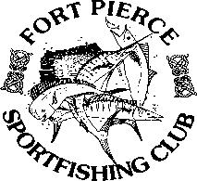
Fort Pierce Sportfishing Club
PO Box 4051
Fort Pierce, FL 34948-4051
Administrative Use Only

Membership # ___________ Date Paid ________________

Check # ___________ Or Cash ________________

